14 January 2019

Epping Forest residents donate £1,750 to local charities through Recycling Rewards

Epping Forest residents have been competing over the last year, completing over 18,000 positive actions to top the Recycling Rewards leader board and donate £1,750 to local charities.
Epping Forest Recycling Rewards is provided by Jump in partnership with Epping Forest District Council, as the leading supplier of sustainability and wellbeing engagement programmes in the UK.
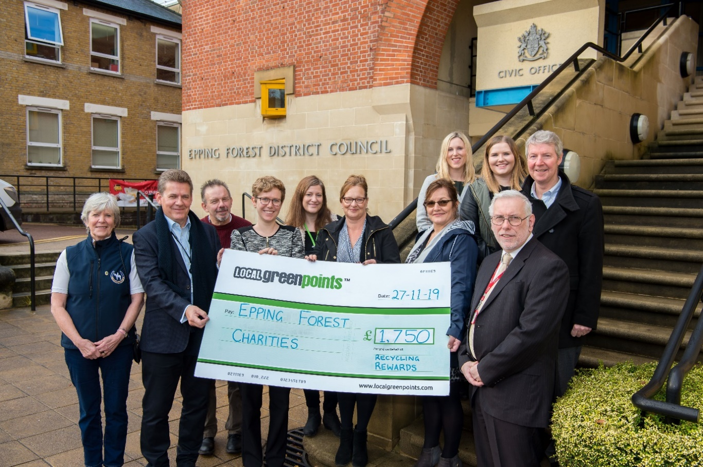
Residents living in 1,500 properties across selected blocks of purpose built flats in Epping Forest compete against each other through Recycling Rewards by taking part in activities such as Food Waste Challenge, Recycling Quiz and ‘Right Thing, Right Bin’. Recycling Rewards aims to reduce contamination and improve the quality of recycling. In the first two years of the programme, an impressive 18,000 positive actions have been recorded as residents have been doing all that they can to improve recycling both in quantity and quality.

Image: charity cheque donation. Left to right: Fran Maskell (Chairperson of Chigwell Riding Trust), Councillor Nigel Avey, Tom Slade (previous Recycling Rewards voucher winner), Cara Watters (Project Coordinator at Jump), Heather Scholer (Project Manager at Epping Forest Food Bank), Bev Kruppa (Epping Forest Community Transport), Laura Ellery (previous Recycling Rewards voucher winner), Rachel Millar (Safer Places representative), David Marsh (Epping Forest District Council Waste and Recycling Manager) and Graham Simmonds (Chief Executive at Jump).
Each month the top six residents who earn the most Green Points win a £25 voucher for reducing, reusing and recycling as much as they can. Over the year individual points all contribute to a community total, with the top scoring community winning the largest share of £1,750 to donate to local charity.
Tom Slade, a resident from Waltham Abbey and one of the monthly voucher winners, has been taking part in Recycling Rewards since November 2017 and is pleased to see the impact of the scheme. He says “I’m a keen recycler and it was nice to win a £25 voucher as this scheme is a great way to get more people recycling across Epping Forest.”
Members of Recycling Rewards vote for the charity which they would like to support. Topping the leader boards for 2019, Waltham Abbey voted for Epping Forest Community Transport to receive £700; Loughton in second place voted for Epping Forest Food Bank to receive £550; Epping in third voted for Safer Places to receive £325; and Buckhurst Hill voted for The Chigwell Riding Trust to receive £175.
Councillor Nigel Avey attended the celebratory event to present the four charities with their donations. He says “it’s great to see how residents in the selected blocks of flats are doing their bit to recycle more as well as improving the quality of recycling by putting the right stuff in the right bin.
“We’ve seen recycling rates increasing in Epping Forest, and it’s a real win-win to be generating donations for local causes whilst increasing the amount of recycled materials.”
Graham Simmonds, Chief Executive at Jump, says “we’re really impressed by the response of residents in these blocks of flats in Epping Forest, and with more people than ever taking part, Epping Forest Recycling Rewards now has one of the highest participation rates in the country for this kind of scheme.”
For the start of the New Year, the leader board has been reset with a brand new competition to kick start 2020.

-Ends-
For further information contact: Sadie Hodgson at sadie.hodgson@teamjump.co.uk or call 020 7326 5055
Jump is the UK’s leading supplier of engagement programmes that boost sustainability and wellbeing. Working with companies, universities and the public sector to motivate individuals to take positive steps, clients include Manchester University NHS Foundation Trust, Barclays, Camden Council, Scottish Courts & Tribunal Service, University of Bristol and Aberdeenshire Council. For more information about Jump, see www.teamjump.co.uk.

