23rd July 2019
10,000 Positive actions and £100 raised for charity through innovative Anglia Ruskin University pilot initiative
Anglia Ruskin University (ARU) has seen a significant improvement in the level of engagement in sustainability and wellbeing amongst a pilot group of 700 employees through its innovative new programme, ARUgreen. Launched in September 2018 as a six month pilot, ARUgreen is an interactive programme that motivates employees to practice behaviours that improve both individual and campus-wide sustainability and wellbeing.
The pilot achieved an impressive 33% participation rate, with employees competing in teams to earn the most ‘Green Points’ through the online platform and app.
The pilot saw 10,000 positive actions including 3,700 lunch time walks, 6,358 reusable cups and bottles used and 51 paperless meetings held. Vouchers were awarded monthly to top points earners, with additional raffle prizes for participants including ARU reusable cups.
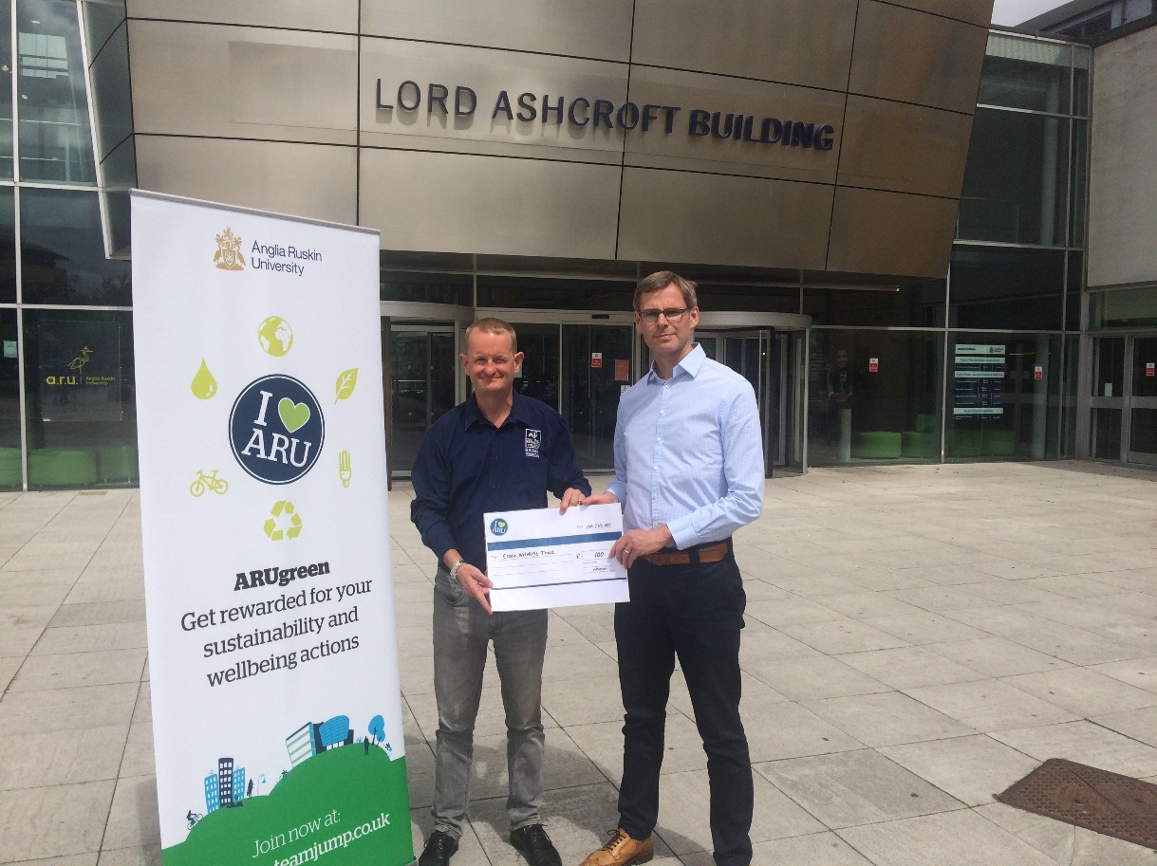
The winning team of the pilot programme, Estates & Facilities, earned the most ‘Green Points’ on average per person. To reward them for their efforts they won a £100 team charity donation prize which they voted to give to the Essex Wildlife Trust.

Photo: Essex Wildlife Trust received a £100 donation from the Estates team at ARU.
L-R: Grant Maton (Corporate Communications Officer, Essex Wildlife Trust) and Simon Chubb (Environmental Manager, ARU).
ARUgreen covers six themes identified as priority areas at the University; Energy Saving, Sustainable Travel, Health and Wellbeing, Responsible Purchasing, Waste and Recycling and Get Involved - within each are a range of activities such as switching off electrical equipment. 70% of participants said the programme had increased their sustainable behaviour at work and 96% agreed it supports the University to reduce its environmental footprint.
After its successful pilot, ARUgreen has now rolled out to all 1,900 employees across the University’s three campuses in Cambridge, Chelmsford and Peterborough, and will be launching to all 17,000 students in September.
Simon Chubb, Environmental Manager at ARU, said: “ARUgreen is a great way for our people to feel part of a network of committed individuals, making a real tangible difference. Our donation to the Essex Wildlife Trust adds to this and makes an even greater difference to the local wildlife and biodiversity. We’re really looking forward to getting students involved in September as they are a key part of driving change at the University.”
Graham Simmonds, Chief Executive at engagement specialist Jump who operate the ARUgreen programme, commented: “10,000 positive actions from a relatively small pilot group of employees is an impressive result and we’re always pleased to see donations going back into environmental projects. I’m looking forward to seeing even wider impact as the programme is rolled out campus-wide for students and employees from September.”
-Ends-
For further information contact: Maya Comely at Jump on maya.comely@teamjump.co.uk or call 020 7326 5055.

Jump is the UK’s leading supplier of engagement programmes that boost sustainability and wellness. Working with companies, universities and the public sector to motivate individuals to take positive steps, clients include Manchester University NHS Foundation Trust, Camden Council, Scottish Courts & Tribunal Service, University of Bristol and Aberdeenshire Council. For more information about Jump, see www.teamjump.co.uk.

