11th April 2022
Nottingham Trent University wins prestigious university impact award for innovative gamification approach to net zero

The race to net zero is no game – or is it? Gamification has been identified as a tool that public sector organisations should use to encourage employees and consumers to make lifestyle changes that positively impact the environment. Gamification refers to using elements of games in non-game settings, such as points, teams, leader boards, and prizes. In a report published by thinktank Public, it is recommended that public sector organisations push forward net zero by creating ‘sustainability contests’ for their consumers that encourage reducing individual carbon emissions. Public states that public sector organisations should achieve this by teaming up with businesses to produce gamification programmes.
With The Climate Change Committee estimating in their 2020 Sixth Carbon Budget report that 62% of remaining emissions reduction will have to occur through individual choices, and the latest IPCC Report stating that the window for stopping 1.5C of warming is rapidly closing – it's easy to see why introducing new tactics to curb personal emissions is a must for businesses.
This has been put into practise by Nottingham Trent University (NTU), whose ‘Green Rewards’ programme was rolled out to staff and students in 2019. NTU collaborated with sustainable employee engagement company Jump to create the Green Rewards app and web platform that use gamification to incite users to adopt sustainable habits. On the platform, users win points for activities such as choosing sustainable transport options, shopping at local green stores, and switching off electronics. Once they’ve earned their points, they can see how they’re performing both as an individual and as a team within their organisation through the platform’s leader boards. Already over 3,700 people are taking part in the programme, with a total 223,563 positive actions achieved to-date which have prevented 32,624 kilograms of waste from going to landfill and 30,340 kilograms of CO2 from entering the atmosphere.
The successful delivery of the gamification programme led to NTU winning the University Impact Initiative of the Year Award on 7th April at the 2022 AUDE Awards (The Association of University Directors of Estates). NTU was selected over eight other finalists.

A figurehead in the delivery of the NTU gamification programme is the University’s Head of Sustainability, Charmaine Morrell, who said:
“Gamification is an important way to engage our staff and students in helping NTU meet its net zero carbon target. The Green Rewards app encourages our staff and students to make more sustainable wellbeing and lifestyle choices in various areas, such as fast fashion, food and drink, active travel and recycling, which translates into points gained and prizes won. The drive for sustainability, friendly competition, and community-based activities are three things that continue to make Nottingham Trent University a positive and progressive place to work and study.”

Simon Smith, Interim Director of Estates at NTU commented:
We’d really like to thank NTU’s colleagues and students for getting behind the programme with such enthusiasm. The entire University, Estates and Sustainability teams are right behind this project and have given it fantastic support. A special thank you goes to the platform provider, Jump

Graham Simmonds, Chief Executive of Jump, says:
“We have been developing our gamified sustainability programmes for over a decade and have seen a sharp rise in interest from public sector organisations that continues to grow. This is both because of the push to go net-zero and also the compelling evidence that gamification is a vital resource in engaging people in sustainability. So much so that we recently won 100k in funding from SBRI Healthcare to develop a gamified employee engagement tool to help the NHS meet its goal to be zero by 2030.”

Editor’s notes:

For further information, contact: Sasha Iles at sasha.iles@teamjump.co.uk or call 020 7326 5055

Jump is an engagement specialist that uses cutting-edge engagement programmes and gamification to boost sustainability and wellbeing. We use our behaviour change model, which has been ten years in the making, to create bespoke programmes for businesses that can be accessed via an app and web platform. This can be targeted for internal staff or external consumers, who are given incentives for making sustainable lifestyle changes. Its clients include Barclays, Manchester University NHS Foundation Trust, Camden Council, Scottish Courts & Tribunal Service, and University of Bristol. In 2021, Jump clients saved on average £87,150 in overhead costs. For more information about Jump, see www.teamjump.co.uk.

Public’s recommendation is on page 67 of the report.

Further context on gamification for sustainability from the Public report: “Oppon-Tawiah et. al. found in 2018 that introducing feedback via a gamified app aided employees to decrease their use of electricity, and that two weeks of monitoring and feedback created habit change. Furthermore, app usage resulted in sharing tips and spillover to other sustainability areas.”

Image 1: Landing page for Nottingham Trent University’s Green Rewards app:
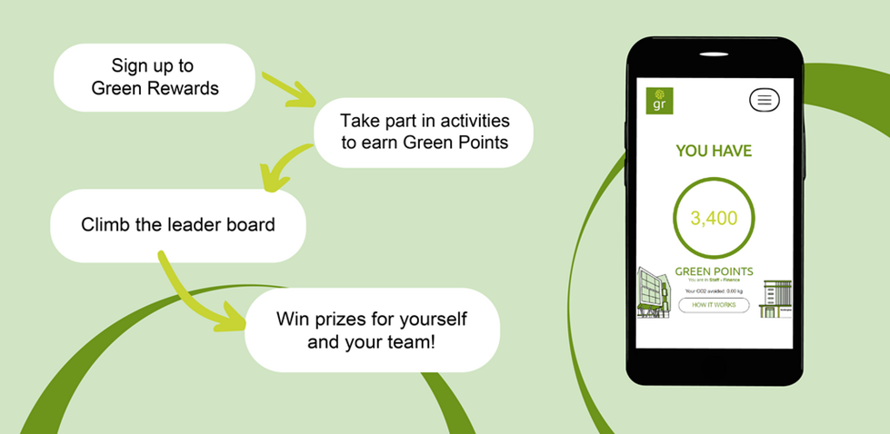
Image 2: Gamification image
Image 3: NTU’s Head of Sustainability, Charmaine Morrell, and the Interim Director of Estates, Simon Smith.
