Green travel capital of the UK? Nottinghamshire leads the way in emission beating public transport
20th July 2022
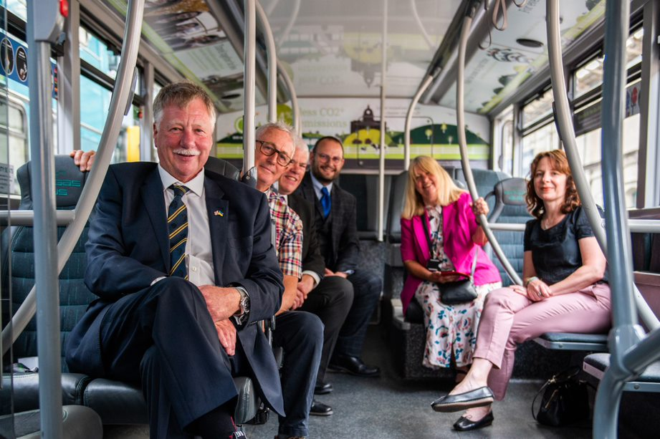

Left to right: Cllr Roger Jackson, Newark and Sherwood District Council; Cllr Ron McCrossen, Gedling Borough Council; Darryl Burch, Service Manager for Neighbourhoods, Rushcliffe Borough Council; Anthony Carver-Smith, Nottingham City Transport Head of Marketing; Cllr Helen E Skinner, Broxtowe Borough Council; Angie Lillistone, Head of Carbon Reduction Projects and Policy, Nottingham City Council. Photo credit: Nathan O’Brien
Figure 1 Nottingham Representatives aboard a NCT bus

A collaboration between Nottingham City Transport, all eight Nottinghamshire Councils and Nottinghamshire County Council may see the county become the green travel capital of the UK. Since 2017, Nottingham City Transport has had the largest fleet of bio-gas double decker buses in the world, due in part to a £42 mil investment by the Company. The latest development will see the organisations work together to make using the green fleet more accessible to Nottinghamshire residents through price reductions. Starting from the 20th July 2022, residents can redeem a 15% discount for adult and group day tickets on NCT buses, while every month, there will be an opportunity to win a monthly NCT bus pass worth £60!
The cost reductions will be available through the councils’ Green Rewards programme – a website and mobile app free for everyone with Nottingham postcodes. The programme has the dual benefit of rewarding residents for adopting other sustainable habits such as choosing active travel methods, reducing waste, and shopping sustainably. This will support the Nottinghamshire Councils and County Council in their work to reduce carbon emissions – and the more residents get involved, the greater impact! Since it launched in October 2021, the councils’ programme has avoided the carbon equivalent of over 5,200 car journeys from Nottingham to London. This figure will continue to grow as more people use the programme.
A 2020 study by KPMG found that since 2015 the total number of journeys per head in Britain declined by 6.7% - approximately 650 million fewer trips per year. The same study also acknowledged that improving the attractiveness of local bus services to UK residents is fundamentally one of the quickest and most effective ways to improve the UK’s net zero trajectory. This highlights the importance of what Nottingham City Transport and the Nottinghamshire councils are trying to achieve with their scheme to get the people of Nottinghamshire ditching the car and choosing public transport. Not only this, but these price reductions will also be a welcome benefit to any residents pinching their pennies due to the cost-of-living crisis. Other councils across the country should look to Nottinghamshire as a success story for implementing travel strategies that improve the lives of local residents as well as boost the trajectory of net zero ambitions.

Anthony Carver-Smith, Head of Marketing of Nottingham City Transport said:
“Sustainability is at the top of our agenda at Nottingham City Transport, and as we start to see people return to bus after the pandemic, our partnership with local councils through the Green Rewards scheme is a great way to encourage more people to travel by bus and make Nottinghamshire the green travel capital of the UK. We can’t wait to see where this collaboration takes us!”

Graham Simmonds, Chief Executive at Jump, said:
“We’re delighted to feature this collaboration on the Notts Green Rewards programme to support residents to adopt more sustainable travel behaviours, and reduce their living costs at this challenging time. It’s an amazing example of what a cohesive effort from local organisations can do for achieving sustainability goals.”

For further information:
Contact sasha.iles@teamjump.co.uk or call on 073844 65717.

About Jump:
Jump is an engagement specialist that uses cutting-edge engagement programmes and gamification to boost sustainability and wellbeing. We use our behaviour change model, which has been ten years in the making, to create bespoke programmes for businesses that can be accessed via an app and web platform. This can be targeted for internal staff or external consumers, who are given incentives for making sustainable lifestyle changes. Its clients include Barclays, Manchester University NHS Foundation Trust, Camden Council, Scottish Courts & Tribunal Service, and Durham University. In 2021, Jump clients saved on average £87,150 in overhead costs. For more information about Jump, see www.teamjump.co.uk.
LinkedIn Twitter

