Survey finds that behaviour change platforms improve employee sustainable habits by 78%
17th October 2022
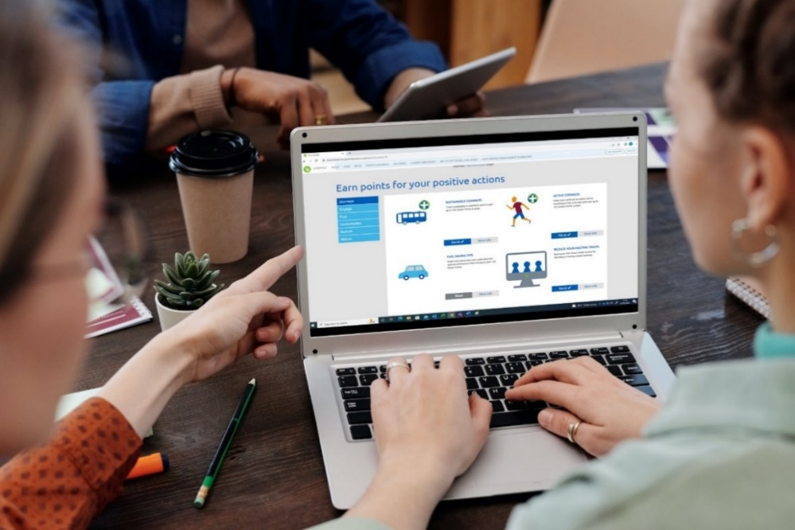

Engaging employees in an organisation’s sustainability strategy and inspiring them act more sustainably has been increasingly on the minds of sustainability managers and HR departments alike. A new report by the House of Lords Environment and Climate Change Committee recommended that if the UK is to meet its net zero targets behaviour change campaigns are needed to help people change behaviours in “key areas” such as sustainable diets and energy use. Following this Jump, the UK’s leading supplier of sustainable employee engagement programmes, has released data from a recent survey of 2,158 of its platform users.
The data from Jump’s survey found that 80% of its users said they are more aware of the impact they have on the environment after using the platform. While 78% of users said that the sustainability actions they perform as part of the platform have become part of their daily and weekly routine – this includes sustainable commuting, energy saving and reducing food waste. The survey also found that users felt their attitude towards sustainability improved the longer they used the platform, with those participating for more than 2 years saying it had improved their attitudes to sustainability by 35%, in comparison to users of less than 6 months stating it had improved their view of sustainability by 23%.
These findings indicate that engaging and educating people in sustainable changes that can be made on a day-to-day basis could empower a huge shift that helps the UK on its way to becoming net zero. Especially considering that in the House of Lords Environment and Climate Change Committee’s report it was highlighted that most Brits do not know the most effective ways to reduce their environmental impact. Behaviour change platforms are an up-and-coming solution for engaging employees in how they can become more sustainable in and out of the workplace. These digital programmes use gamification, education, and behaviour change theory to create new habits in users. These platforms is already proving to be popular in organisations with ambitious net zero targets, such as the NHS, who have a 2030 – 2040 net zero target.

Graham Simmonds, Chief Executive at Jump says:
“Behaviour change is absolutely necessary if we are to meet our net zero targets. We cannot carry on business as usual, especially in the midst of 40 degree summers in the UK which will continue to rise the longer we avoid taking action. People need to be given the tools so that they can equip themselves with knowledge and act in their daily lives. We need everybody, everywhere doing what they can to save our planet.”

For further information:
Contact sasha.iles@teamjump.co.uk or call on 073844 65717.

About Jump:
Jump is an engagement specialist that uses cutting-edge engagement programmes and gamification to boost sustainability and wellbeing. We use our behaviour change model, which has been ten years in the making, to create bespoke programmes for businesses that can be accessed via an app and web platform. This can be targeted for internal staff or external consumers, who are given incentives for making sustainable lifestyle changes. Its clients include Barclays, Manchester University NHS Foundation Trust, Camden Council, Scottish Courts & Tribunal Service, and the University of Bristol. In 2021, Jump clients saved on average £87,150 in overhead costs. For more information about Jump, see www.teamjump.co.uk.
LinkedIn Twitter

