Gloucestershire Wildlife Trust is using gamification to boost community engagement
31st August 2022
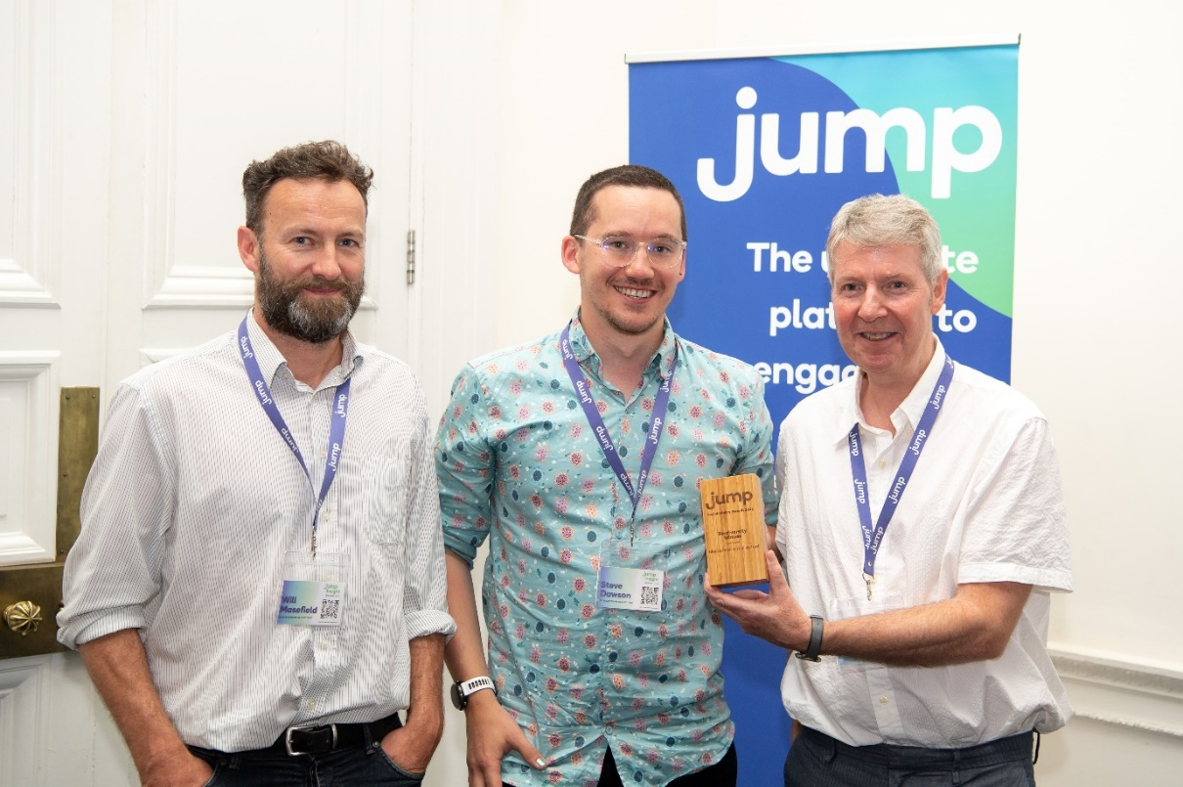
GWT won the Biodiversity Award at the Jump Awards 2022 for their programme. (L-R) Will Masefield, Head of Engagement at GWT, Steve Dawson, Community Action Officer at GWT, and Graham Simmonds, CEO of Jump who provide the WilderGlos programme.

Britain is one of the most nature depleted countries in the world, 41% of species are in decline and 15% are at risk of extinction (source), with immediate action needed to stop hedgehogs, water voles, and red squirrels from disappearing forever. This is something The Wildlife Trusts plan to change with their strategy to put nature in recovery by 2030, but like many charities, they need community engagement to get there. To achieve this, one Trust has turned to innovative methods to engage the community: gamification. That Trust is Gloucestershire Wildlife Trust, who aim to engage one in four people in Gloucestershire. This has led them to invest in an online gamification programme called ‘WilderGlos’ where residents are rewarded for helping nature thrive.
Gamification refers to using elements of games in non-game settings, such as points, teams, leader boards, and prizes. It has been identified as a tool that organisations should be using to encourage consumers to make lifestyle changes that positively impact the environment (source). The WilderGlos programme sees users participate in activities such as: creating a wildlife pond, planting a tree, lobbying their local MP, and avoiding car travel. These activities gain them points, which give them a place on the leader board and ultimately, monthly prizes for the top points earner. Their ‘People’s Nature Reserve’ activity has seen residents rewild areas of their garden, which accumulate to the size of almost two football pitches so far.
On 13th July 2022 GWT won the ‘Jump Biodiversity Award’ at the Jump Awards 2022. Jump is the provider of GWT’s bespoke digital engagement programme and runs similar programmes for organisations such as Barclays, Durham University, and multiple NHS Trusts, however this is their first third sector programme. Jump’s Chief Executive Graham Simmonds thinks that engagement programmes could become a key tool for third sector organisations in the future, as they are community engagement is at the core of charitable work.

Graham Simmonds, Chief Executive at Jump says:
“Biodiversity loss is one of the greatest threats of our lifetime, so seeing GWT’s dedication to engaging Gloucestershire residents in this issue has been amazing. Gamification is an incredibly powerful tool for reaching people from all walks of life and acts as a great bridge to engaging people in a wide range of issues. We hope to see lots of other organisations using it as a community engagement tool in the future.”
Will Masefield, Head of Engagement at GWT says:
“At GWT we want to mobilise 20,000 people in Gloucestershire to take action for wildlife so that nature is in recovery by 2030. The WilderGlos programme has been an effective tool in helping us towards this goal and seeing the community action as a result has been great.”

For further information:
Contact sasha.iles@teamjump.co.uk or call on 073844 65717.
About Jump:
Jump is an engagement specialist that uses cutting-edge engagement programmes and gamification to boost sustainability and wellbeing. We use our behaviour change model, which has been ten years in the making, to create bespoke programmes for businesses that can be accessed via an app and web platform. This can be targeted for internal staff or external consumers, who are given incentives for making sustainable lifestyle changes. Its clients include Barclays, Manchester University NHS Foundation Trust, Camden Council, Scottish Courts & Tribunal Service, and the University of Bristol. In 2021, Jump clients saved on average £87,150 in overhead costs. For more information about Jump, see www.teamjump.co.uk.
LinkedIn Twitter

